

Section 1: Team Members and Contributions

Ajay Vishwanatha | Model Exploration, LightGBM, Text Engineering, Business Feature Engineering, Report
Chia-Hsuan Chang | Model Exploration, HistGradientBoosting, Linear Model, Compile/Comment and Clean up code, User Feature Engineering
Jacob Lourie | Model exploration, Gradient Boosting and Random Forest model, Text Mining, Tip Feature Engineering
Kurumi Sato | Model Exploration, Random Forest, XGBoost, Feature Engineering, Business Feature Engineering, Report
Yuzhe Tian | Model Exploration, Ensemble Models, and User Feature Engineering

Section 2: Business Understanding
Online review platforms have changed how consumers make purchasing decisions and how businesses attract customers. Yelp uses hundreds of millions of reviews to help customers rate businesses, but not all reviews carry equal weight. Roughly 15% of reviews were identified as highly useful and they help guide decisions and carry stronger influence.
Our model predicts whether a Yelp review is likely to earn a highly useful tag. Factors such as the reviewer's review history, the business category, the review’s lengt and text quality contribute to whether a review is ultimately flagged as highly useful. This capability has significant value for businesses across many industries. For business owners, a single highly useful negative review can suppress foot traffic for weeks to months. Additionally, this can also impact digital marketing agencies and Yelp itself.
The primary users of this model are Yelp’s data science and product teams. The constraint on FPR being less than 10% reflects the need for a consistently reliable model. This is to prevent incorrectly promoting low-quality reviews, which damages user trust and hurts business reputations. Yelp could use real-time usefulness predictions to re-rank reviews shown to browsing users, showing the most informative content first rather than relying solely on recency. It will also prevent customers from navigating through unhelpful reviews, which wastes time and slowly creates distrust within the platform.
Additionally, companies running other businesses' Yelp profiles and creating paid reviews could use the model's feature importances to understand what makes a review compelling and craft their own customer review templates accordingly. If the model reveals that reviews mentioning specific service attributes, staffing quality, or value comparisons tend to become highly useful, a marketing team can let the business know to include those elements when soliciting organic reviews to improve their rating.
An effective model for predicting top-useful reviews creates value for not only Yelp but also businesses. As a company, Yelp finds value in the model as it automates the decision on whether a review is considered useful and can bring the review higher to the business's review page, rather than waiting for other users’ votes on whether that review was helpful. Yelp can push better reviews, making it more reliable, and can help speed up its decision-making time. For Yelp users, improve the content they see, which can compound over time. If the most helpful reviews are consistently shown first, users make better decisions, trust the platform more, and have a desire to contribute higher-quality content themselves. Lastly, for businesses, bad reviews can affect the growth of their business, and good reviews can attract more customers.
Predicting review usefulness helps business owners build consumer trust. Our model converts an observable community signal into a predictive asset that can be deployed in real time, generating value for platforms, businesses, and end users alike. We can address every industry sector present on Yelp, but the underlying methodology is transferable to any review ecosystem where usefulness, helpfulness, or quality signals are collected.

Section 3: Data Understanding and Data Preparation

Yelp Dataset
ID | Feature Name | Brief Description | Block & Code Line
1 | BusinessAcceptsCreditCards | Original feature from the dataset | Block 7, Line 67-142
2 | BikeParking | Original feature from the dataset | Block 7, L 67-142
3 | ByAppointmentOnly | Original feature from the dataset | Block 7, Line 67-142
4 | RestaurantsReservations | Original feature from the dataset | Block 7, Line 67-142
5 | RestaurantsGoodForGroups | Original feature from the dataset | Block 7, Line 67-142
6 | RestaurantsTakeOut | Original feature from the dataset | Block 7, Line 67-142
7 | GoodForKids | Original feature from the dataset | Block 7, L 67-142
8 | HasTV | Original feature from the dataset | Block 7, L 67-142
9 | Caters | Original feature from the dataset | Block 7, L 67-142
10 | RestaurantsDelivery | Original feature from the dataset | Block 7, Line 67-142
11 | RestaurantsTableService | Original feature from the dataset | Block 7, Line 67-142
12 | WheelchairAccessible | Original feature from the dataset | Block 7, Line 67-142
13 | DogsAllowed | Original feature from the dataset | Block 7, L 67-142
14 | OutdoorSeating | Original feature from the dataset | Block 7, L 67-142
15 | HappyHour | Original feature from the dataset | Block 7, L 67-142
16 | log_business_review_count | Log of the number of reviews the business has | Block 7, Line 77
17 | RestaurantsAttire | One hot encoding of original feature from dataset | Block 7, Line 144-154
18 | Alcohol | One hot encoding of original feature from dataset | Block 7, Line 145-157
19 | Noise | One hot encoding of original feature from dataset | Block 7, Line 146-161
20 | days_open | Number of days each week business is open | Block 7, L 167-208
21 | WiFi | One hot encoding of original feature from dataset | Block 7, Line 147-165
22 | attr_RestaurantsPriceRange2 | Original feature from the dataset | Block 7, Line 150-231
23 | compliment_count | Number of compliment tips | Block 9, Line 15-34
24 | log_user_friend_count | Log of the number of friends | Block 11, Line 15
25 | star_diff_from_business | Star difference between the business and the review | Block 11, Line 7
26 | user_star_diff | Star difference between the review and the average stars the user gives | Block 11, Line 8
27 | abs_star_diff_from_business | Absolute difference between the average stars for the business and the review | Block 11, Line 10
28 | abs_user_star_diff | Absolute difference between the average stars given by the user and the review | Block 11, Line 11
29 | review_len_x_user_review_count | Log of the number of user reviews multiplied by the log of text length of review | Block 11, Line 13-46
30 | log_user_fans | Log of the user fans | Block 11, Line 14
31 | log_user_elite_count | Log of the user elite count | Block 11, Line 16
32 | user_tip_x_text_len | Log of user tip count multiplied by the log of the text length | Block 11, Line 65
33 | is_extreme_star | Whether the rating is below 2 or above 5 stars | Block 5, Line 91
34 | is_positive_star | Whether the rating is at or above 4 stars | Block 5, Line 92
35 | is_negative_star | Whether the rating is at or below 2 stars | Block 5, Line 93
36 | review_dayofweek | The number of years the user has been labeled elite | Block 5, Line 72-78
37 | log_text_x_log_business_reviews | Log of text length multiplied by log of the number of business reviews | Block 11, Line 54
38 | log_word_x_log_business_reviews | Log of word count multiplied by log of the number of business reviews | Block 11, Line 55
39 | avg_hours_per_day | Average hours that the business is open each day | Block 7, Line 197-209
40 | yelping_since_year | First year the user joined Yelp | Block 8, Line 8
41 | user_elite_count | Number of years the user has been labeled elite | Block 8, Line 20-29
42 | positive_word_count | Number of positive words in the review | Block 6, Line 57-65
43 | negative_word_count | Number of negative words in the review | Block 6, Line 61-66
44 | business_stars | Number of stars the business has | Block 7, Line 71
45 | business_review_count | Number of reviews a business has received | Block 7, Line 72
46 | category_count | Number of categories a business has | Block 7, Line 84-219
47 | latitude | Business location’s latitude | Block 7, Line 74-217
48 | longittude | Business location’s longitude | Block 7, Line 75-218
49 | is_weekend | Indicate whether the review was written on a weekend | Block 6, Line 78-84
50 | review_dayofweek | Day of the week the review was written | Block 6, Line 76-82

External Holiday Dataset
ID | Feature Name | Brief Description | Block & Code Line
1 | is_us_holiday | Was this Yelp review written on a U.S. holiday? | Block 5, Line 8-78
2 | days_to_nearest_holiday | Number of days between Yelp review and the nearest holiday | Block 5, Line 8-78
3 | days_since_previous_holiday | Number of days between Yelp review and the previous holiday | Block 5, Line 8-78
4 | days_until_next_holiday | Number of days between Yelp review and next holiday | Block 5, Line 8-78
5 | is_holiday_window_3 | Was this Yelp review written within a 3-day window of a U.S. holiday? | Block 5, Line 8-78
6 | is_holiday_window_7 | Was this Yelp review written within a 7-day window of a U.S. holiday? | Block 5, Line 8-78

Graphs or tables demonstrating useful or interesting insights regarding features in the dataset
Interesting that the lower the review stars, the higher the rate it has for top usefulness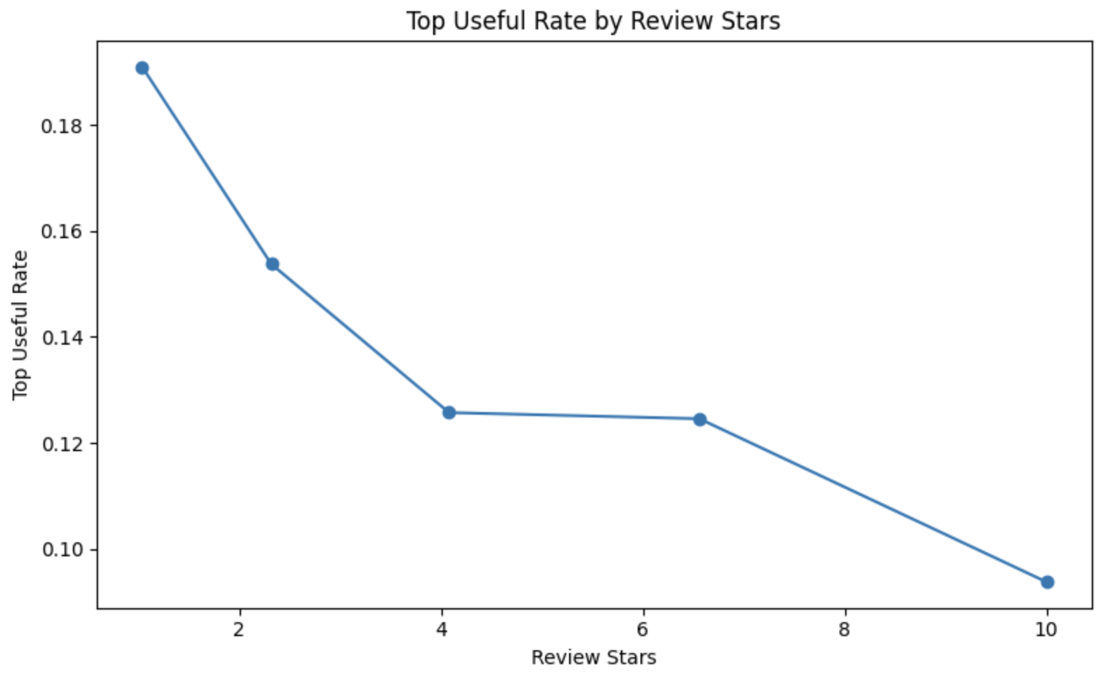

Most businesses on Yelp are categorized as food or restaurants, and very few do not have a category.
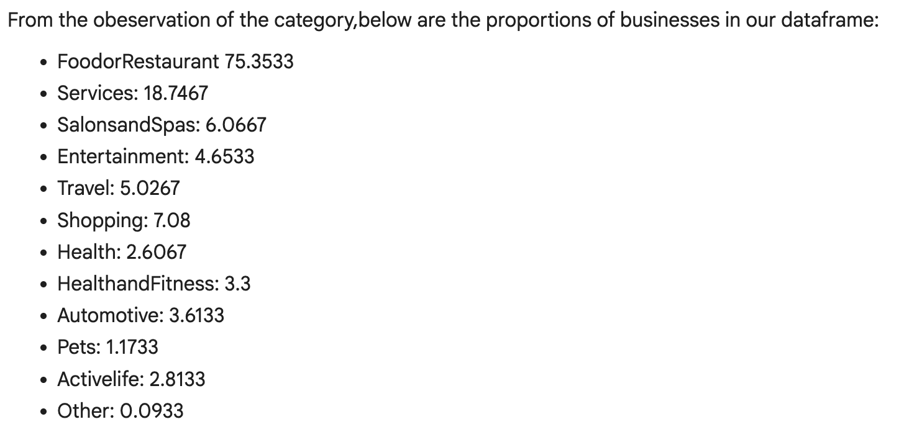
Breakdown of different businesses. Interestingly, most businesses seem like they are Mexican restaurants, and the next are pizza and then Chinese restaurants. 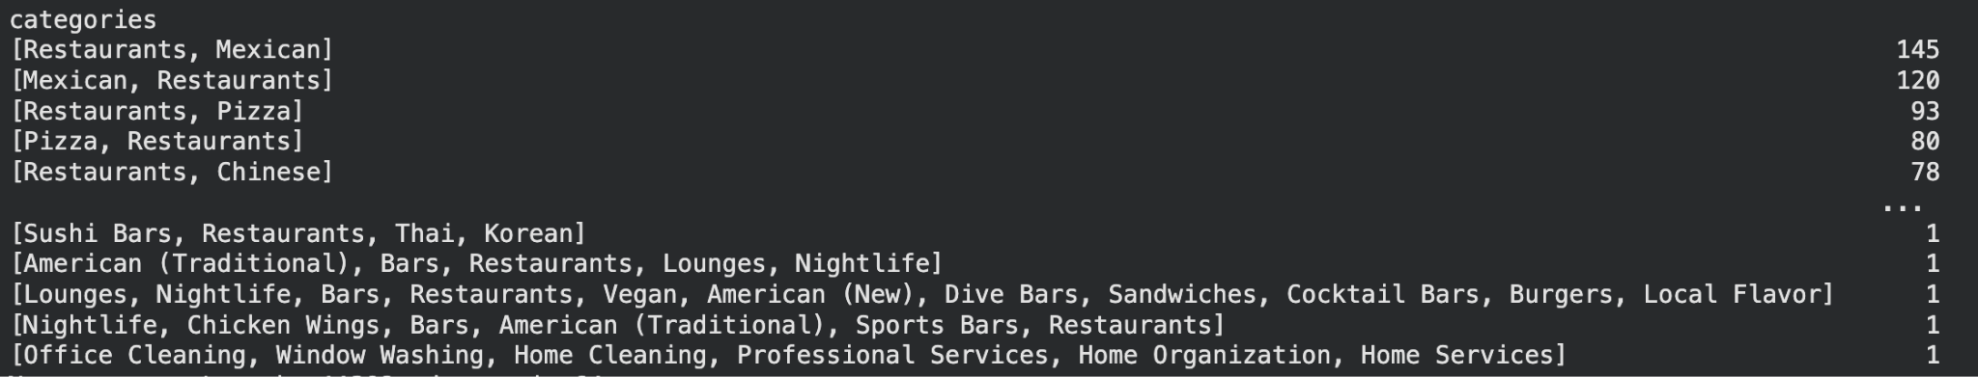

Looking at our standard deviation, we found that the average stars for all Yelp reviews are 6.19 stars. This might give us some insights that many reviews left on Yelp steer negatively, or that many users have high standards. Looking at the review count feature, the standard deviation is quite large.
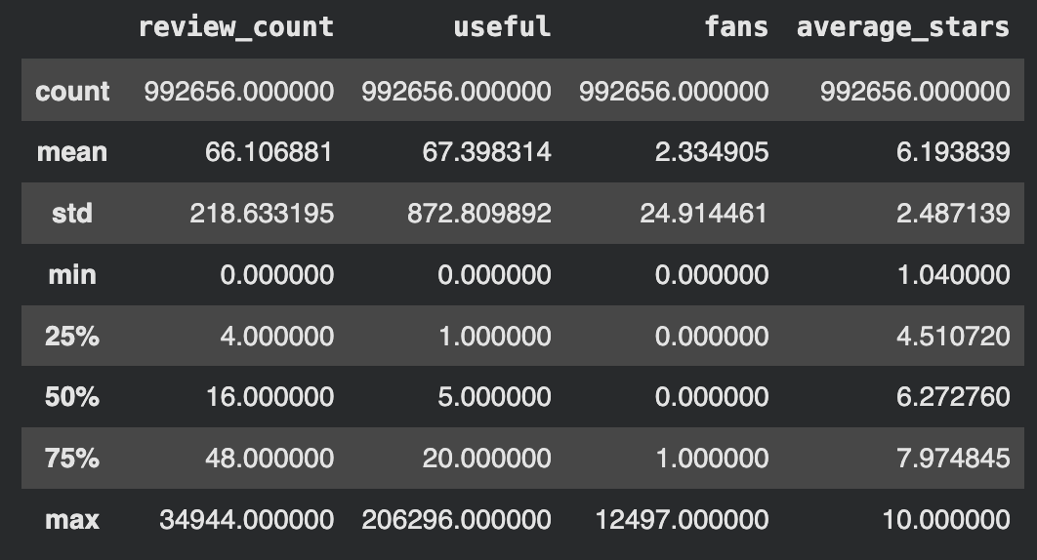

The category with the largest number of missing hours is automotive, pets, and salons/sppas
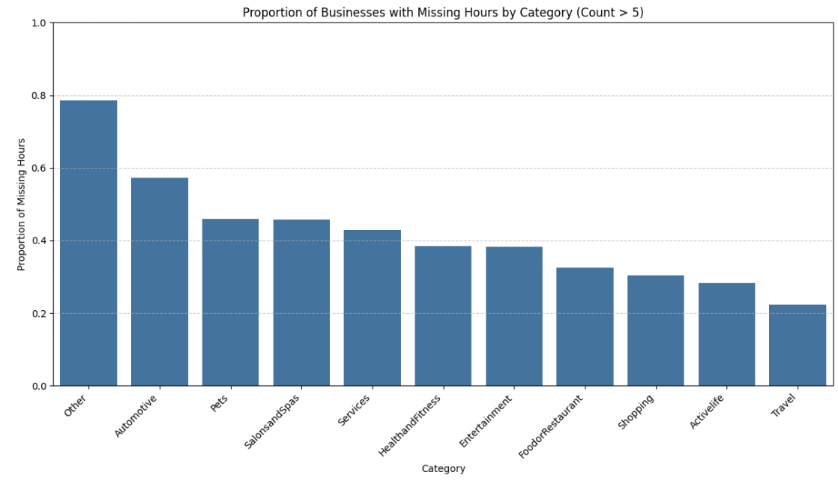
PA has more than double the number of businesses than the 3rd highest state. FL is second with about 70% of the number PA has. The rest of the states in the top 10 fall within a close range
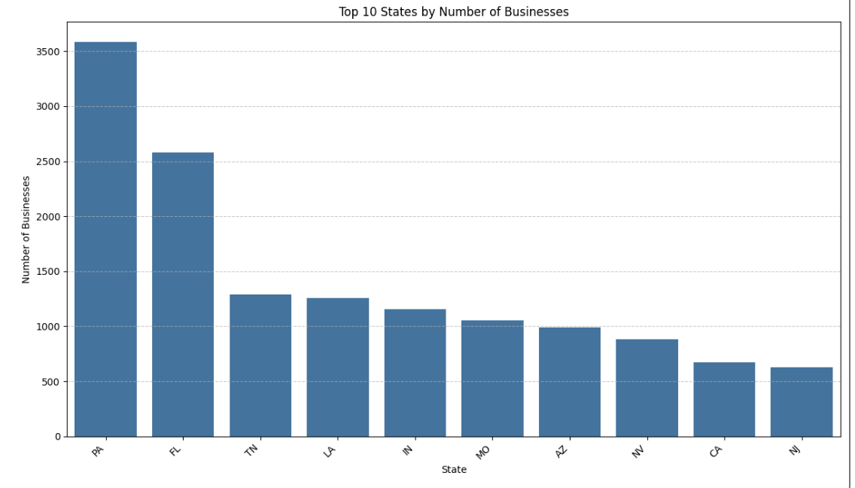

Find the difference between when a model is and is not useful. We found that the range is the largest for the user review count. The mean is barely affected between useful or not during the holiday window for 7 days.
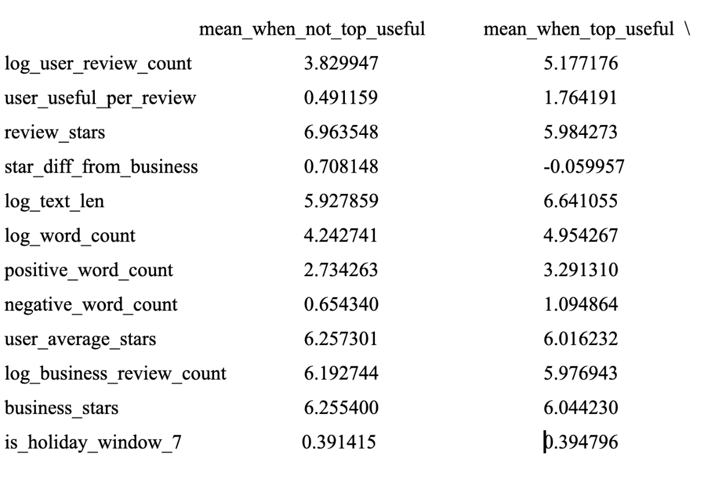
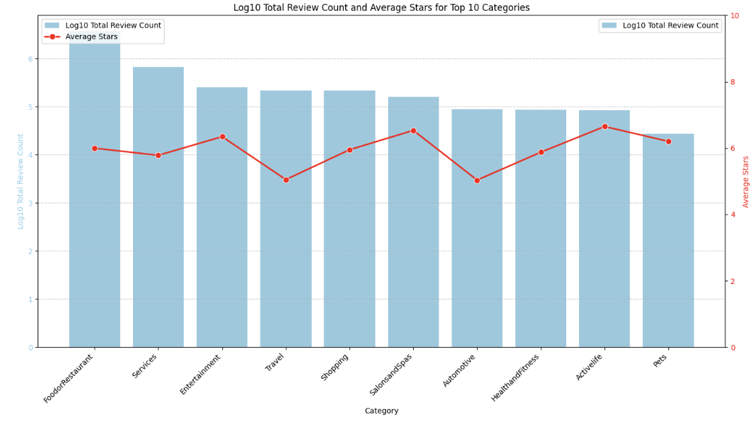
After binning our elite years, we found that over 92% of users were not classified as elite. However, among the elites, most have been holding the status for 3-5 years.
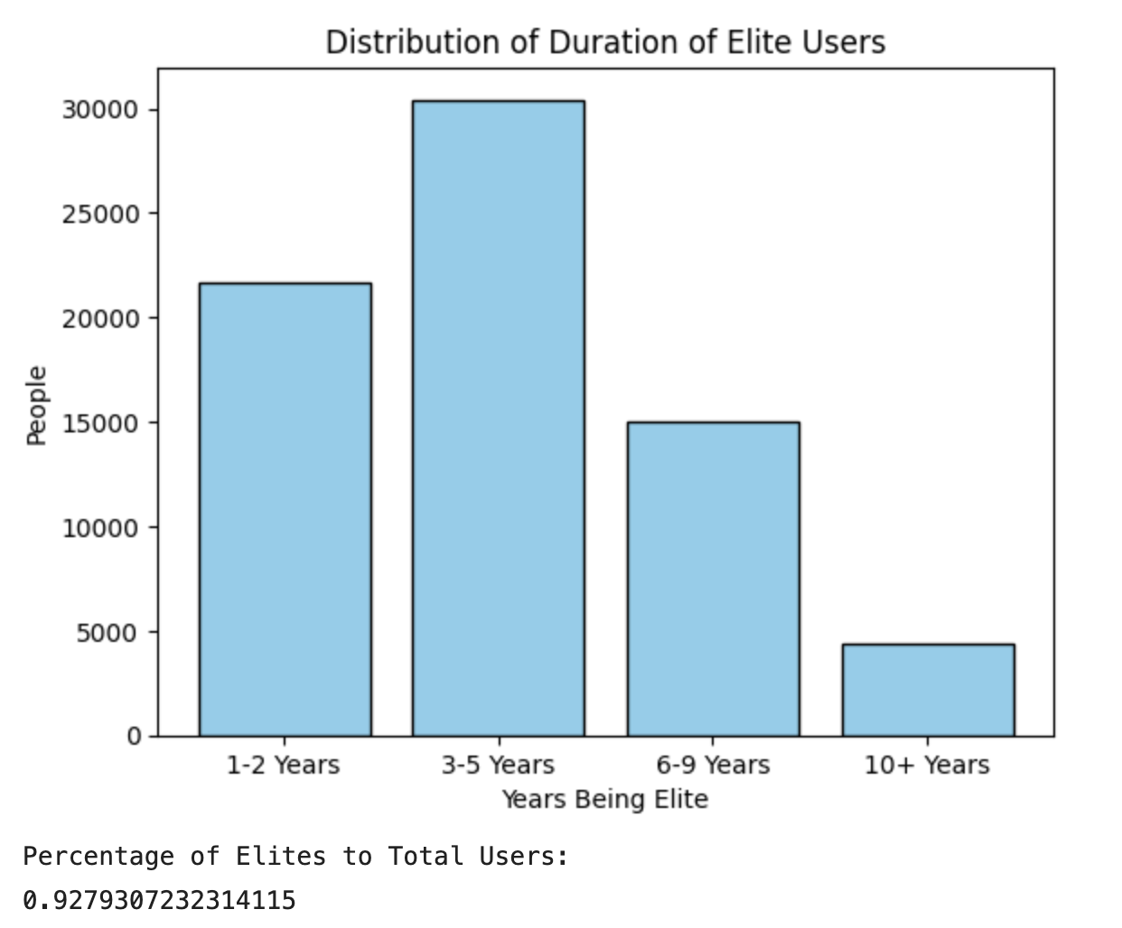

Additional comments about the data or the steps you undertook for data preparation.
For our data preparation, we cleaned each individual CSV file to reorganize the columns so that the data was easier to manipulate, and also selected any important features and completed any necessary feature engineering. We created bins, cleaned any NA values, and found a general distribution of all of the features we were using to note any columns that could be useful or would affect the accuracy of our model. We did one-hot encoding to ensure that any categories that used text, such as noise level we made into an integer scale where each noise level was associated with an integer. We did a final check to make sure all columns and attributes did not have similar or is a duplicate
We also created many other features, such as differences in review stars between what the business usually receives, what customers typically rate businesses, and what rating that specific review gave. This gives us a better understanding of what the rating actually means, since many reviewers have a different scale and understanding of what 4 vs 5 stars means.

When cleaning our data, we found it interesting that there were only two missing postal codes compared to the 145 businesses that were missing addresses entirely. We were able to find the postal codes since the two missing postal code rows had an address!
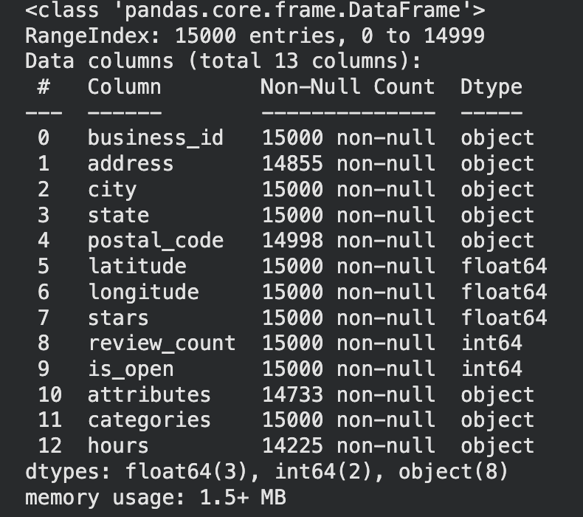

The Summary of the ten features we explored:
- Lower-star reviews had a higher top-useful rate.
- Food and restaurant businesses dominated the dataset.
- Mexican, pizza, and Chinese restaurants were among the most common categories.
- Business review count had high variability.
- Missing business hours were concentrated in automotive, pets, and salons/spas.
- Pennsylvania had the largest number of businesses.
- User review count showed the largest difference between useful and non-useful reviews.
- Holiday-window indicators showed a limited difference between useful and non-useful reviews.
- Over 92% of users were not elite.
- Among elite users, most held elite status for 3 to 5 years.

Section 4: Evaluation and Modeling
The table below summarizes the main results reported in the draft. Metrics are interpreted using the positive class as the target event. TPR measures the share of actual positive cases correctly identified, while FPR measures the share of negative cases incorrectly flagged as positive. Because the project emphasizes performance at or below a 10% false-positive rate, TPR at approximately 10% FPR is the most important comparison metric across models.

Model / Experiment | Feature Set | AUC | FPR | TPR / Recall | Interpretation
Logistic Regression | Business-only | 0.5938 | 0.1000 | 0.2020 | Weak baseline; limited signal from business only features.
Decision Tree | Business-only | 0.7017 | 0.1000 | 0.3128 | Improved over logistic regression, but still limited.
Random Forest | Full merged features | 0.8685 | 0.0436 default | 0.4267 default | Strong AUC; ROC thresholding can raise recall near 10% FPR.
LightGBM CV with improved features | Improved full engineered features | 0.9109 mean CV | 0.1000 target | 0.7054 mean CV | Improved standalone LightGBM; higher AUC and TPR than the earlier LightGBM CV run.
HistGradientBoosting CV | Full engineered features | 0.8953 mean / OOF | 0.0950 mean | 0.6469 mean | Competitive gradient boosting model, but below LightGBM CV TPR.
Logistic Regression | Full merged features, no external data | 0.8805 | 0.1000 | 0.6374 | Feature engineering dramatically improved linear baseline.
Logistic Regression | Full merged features + external dataset holidays | 0.8805 | 0.1000 | 0.6375 | Nearly unchanged from no-holiday version; holiday features had a small but meaningful lift for this model.
Top-K Blended Model | Full pipeline + model zoo blend | 0.879 validation / 0.8953 OOF | 0.0970 | 0.7352 | Best final operating point.

Business-Only Baseline Models

1.1 Logistic Regression Baseline

The first model used logistic regression on the cleaned business dataset. This created a simple and interpretable baseline for testing whether the business-level variables alone contained enough predictive signal.

Metric | Value
Target FPR | 0.1000
Actual FPR | 0.1000
TPR at ~10% FPR | 0.2020
Threshold | 0.1706
ROC-AUC | 0.5938

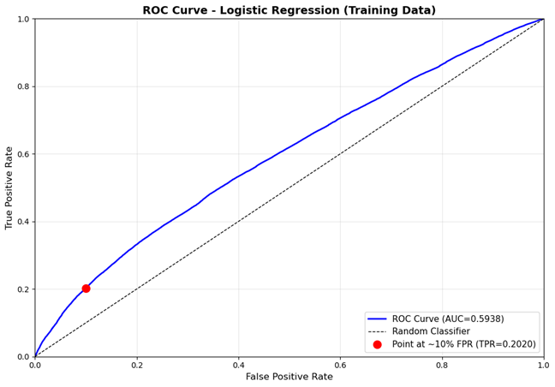
Figure 1. Business-only logistic regression ROC curve. The curve is only moderately above the random baseline, with AUC = 0.5938 and TPR = 0.2020 at 10% FPR.
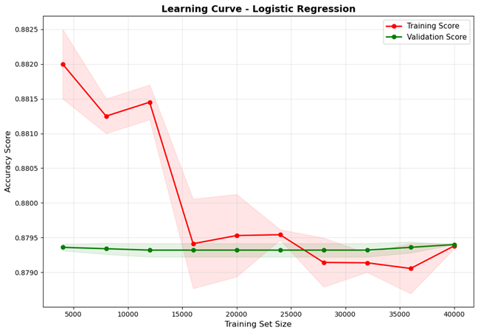
Figure 2. Business-only logistic regression learning curve. Training and validation accuracy remain close and nearly flat, suggesting limited model capacity and limited signal from this feature set.
Inference: The business-only logistic regression model performed only slightly better than random ranking. At the 10% FPR operating point, it captured about 20.2% of the positive cases, which is too low for a strong production model. The learning curve also suggests that the issue is not simply a lack of training data; rather, the model and/or the feature set does not capture enough of the predictive structure.

1.2 Decision Tree Baseline
A decision tree was trained on the same business-level features to test whether a non-linear model could capture interactions that logistic regression missed.
Metric | Value
Target FPR | 0.1000
Actual FPR | 0.1000
TPR at ~10% FPR | 0.3128
Threshold | 0.2016
ROC-AUC | 0.7017

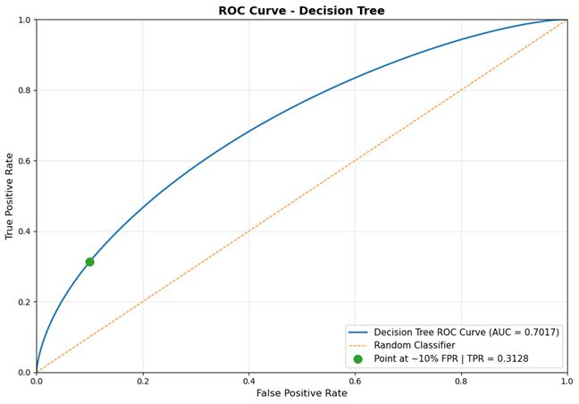
Figure 3. Decision tree ROC curve. The decision tree improves AUC to 0.7017 and TPR to 0.3128 at 10% FPR.

Inference: The decision tree outperformed the business-only logistic regression model. TPR at 10% FPR increased from 0.2020 to 0.3128, a gain of 0.1108 points, or roughly 54.9% relative improvement. This indicates that non-linear splits and feature interactions were useful. However, the model still missed most positive cases at the target FPR, so the business-only feature set was not sufficient.

Full Feature Engineering: Business, User, and Tips/Review Features
The next modeling stage merged the cleaned business, user, and tips/review-derived datasets. This expanded the feature space and allowed models to learn from business characteristics, user behavior, and interaction-level information. This feature engineering step produced the largest improvement in model performance across the project.

2.1 Baseline Random Forest
A baseline Random Forest model was trained to test how an ensemble of decision trees would perform on the richer dataset. Random Forests reduce the variance of individual trees by averaging predictions across many bootstrapped trees and random feature subsets.

Metric | Value
Validation Accuracy | 0.8922
Validation AUC | 0.8685
TPR / Recall at default threshold | 0.4267
FPR at default threshold | 0.0436
Precision for class 1 | 0.57
F1-score for class 1 | 0.49

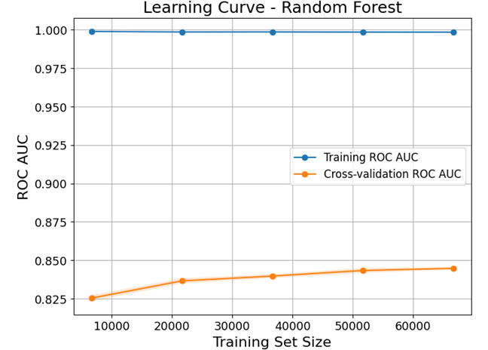
Figure 4. Random Forest learning curve. Training AUC is essentially 1.0, while cross-validation AUC stays much lower and increases slowly, indicating overfitting.
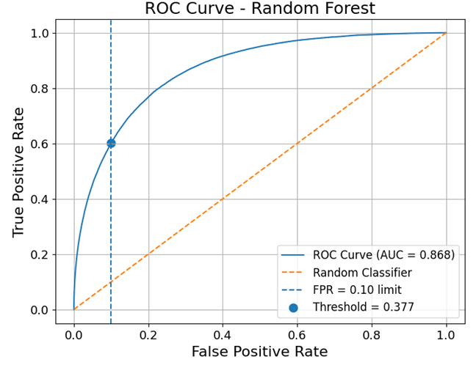
Figure 5. Random Forest ROC curve. AUC is approximately 0.868. The chart indicates that a threshold near 0.377 can achieve roughly 60% TPR at the 10% FPR limit, which differs from the conservative default-threshold recall of 42.67%.

Inference: The Random Forest performed much better than the business-only models, showing the value of the merged feature set. However, the learning curve shows a large gap between training and cross-validation AUC. This is a classic sign of overfitting: the model fits the training data almost perfectly but does not generalize at the same level. The ROC curve also shows why threshold selection matters. The default threshold produced FPR = 4.36% and recall = 42.67%, but moving the threshold to the 10% FPR operating point would increase recall substantially.

3. Gradient Boosting Models

3.1 LightGBM with Cross-Validation
LightGBM was introduced to improve efficiency and predictive performance on the high-dimensional engineered dataset. Gradient boosting builds trees sequentially, where each new tree focuses on correcting the errors of the previous trees. This usually performs well on tabular classification problems.
Hyperparameter | Value / Grid
n_estimators | 700
learning_rate | 0.04
min_child_samples | 100
num_leaves grid | [15, 31, 63, 127, 255]
CV sample | 400,000 rows x 161 features
CV folds | 5-fold stratified CV

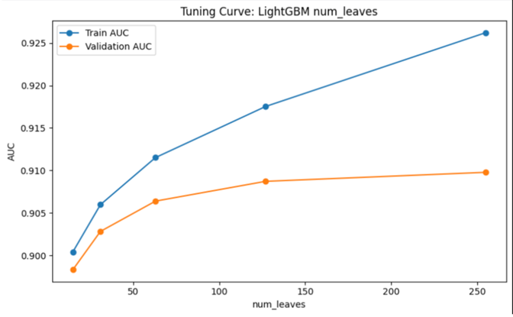
Figure 6. LightGBM num_leaves tuning curve. Validation AUC improves as num_leaves increases, but gains become smaller while the train-validation gap grows.
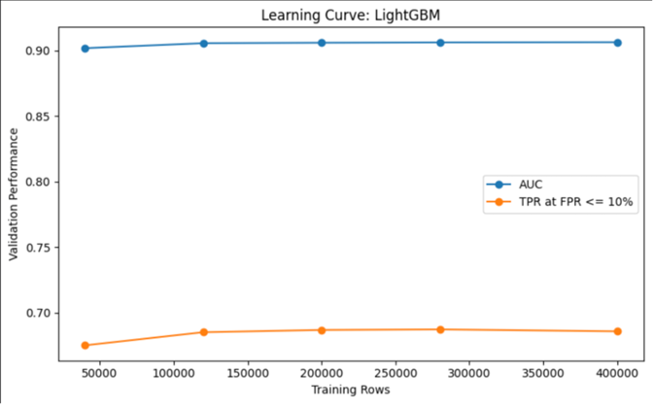
Figure 7. LightGBM learning curve. AUC and TPR improve sharply up to roughly 120,000 training rows and then plateau, suggesting additional rows beyond that point add limited lift for this configuration.

CV Metric | Mean Value
AUC | 0.906911
FPR | 0.096946
TPR | 0.685178

Inference: LightGBM delivered the strongest single-model cross-validation result in the draft, with mean AUC = 0.9069 and mean TPR = 0.6852 while keeping mean FPR just under 10%. The tuning curve shows that validation AUC is highest at 255 leaves among the tested values, not 127. However, the improvement from 127 to 255 is small, while the train AUC continues to rise more sharply. Therefore, 127 leaves can be defended as a more conservative complexity choice, but the chart alone does not prove it is the best validation-AUC value.

3.2 LightGBM with 5-Fold CV and Improved Features
A second LightGBM experiment was run using a stronger feature set and 5-fold cross-validation. This model used early stopping, allowing each fold to continue training until the validation AUC stopped improving for 50 rounds. Early stopping is useful because it lets the model benefit from additional boosting rounds while reducing the risk of training far beyond the point of validation improvement.
Hyperparameter | Value / Grid
Model | LightGBM
Objective | binary
Evaluation metric | auc
Boosting Type | gbdt
Learning Rate | 0.05
Number of Leaves | 31
Feature Fraction | 0.8
Bagging Fraction | 0.8
Bagging Frequency | 5
Number of Jobs | -1
Random State | 42
Verbose | -1
Cross-Validation | 5-fold Stratified CV

The validation logs show consistent performance across folds. Validation AUC reached approximately 0.909 to 0.913 across the five folds, and TPR at the 10% FPR operating point ranged from 0.7000 to 0.7140. This consistency indicates that the improved features generalized well across different validation splits rather than depending on one unusually favorable split.

Fold | Best iteration | Validation AUC | TPR at 10% FPR
1 | 484 | 0.9092 | 0.7000
2 | 854 | 0.9118 | 0.7065
3 | 563 | 0.9110 | 0.7047
4 | 577 | 0.9098 | 0.7017
5 | 1000 | 0.9128 | 0.7140
Mean | - | 0.9109 | 0.7054 +/- 0.0049
Table 4. LightGBM with improved features: 5-fold CV results. The model achieved mean TPR = 0.7054 at the 10% FPR operating point, improving on the earlier LightGBM CV result of 0.6852.

Inference: The improved-feature LightGBM model became the strongest standalone model in the report. Compared with the earlier LightGBM CV run, mean TPR at 10% FPR increased from 0.6852 to 0.7054, an absolute lift of about 0.0202 points. Mean CV AUC also increased from 0.9069 to approximately 0.9109. The training AUC remained higher than validation AUC, which is expected for a boosted tree model, but the validation scores were stable and strong. Fold 5 reached the maximum 1,000 iterations without early stopping and produced the best validation AUC and TPR, suggesting that additional rounds may still help under some folds, although this should be balanced against overfitting risk.

3.3 HistGradientBoosting
HistGradientBoosting was also tested as another gradient boosting approach. It bins continuous features into histograms, which can make training faster and memory-efficient on larger tabular datasets.

Metric / Hyperparameter | Value
Mean AUC | 0.8953
OOF AUC | 0.8953
Mean TPR at FPR <= 10% | 0.6469
Mean FPR | 0.0950
Final threshold | 0.6895
learning_rate | 0.01
max_iter | 1000
max_depth | 12
min_samples_leaf | 20
l2_regularization | 0.05

Inference: HistGradientBoosting was competitive, but it did not outperform the LightGBM cross-validation result. Its mean TPR of 0.6469 at FPR <= 10% is strong compared with the early baselines, but below the LightGBM mean TPR of 0.6852.

4. Full-Feature Logistic Regression and External Holiday Features
A logistic regression model was then trained on the full feature-rich dataset. This created a linear baseline using the business, user, and tips/review-derived variables. The model was tested both without and with holiday-derived external features.
Version | AUC | FPR | TPR | Threshold | Accuracy
Without holiday features | 0.880496 | 0.099969 | 0.637448 | 0.666320 | 0.868210
With holiday features | 0.880487 | 0.099997 | 0.637500 | 0.666259 | 0.868191
Difference | -0.000010 | +0.000029 | +0.000052 | -0.000061 | -0.000019

5. Final Blended Model
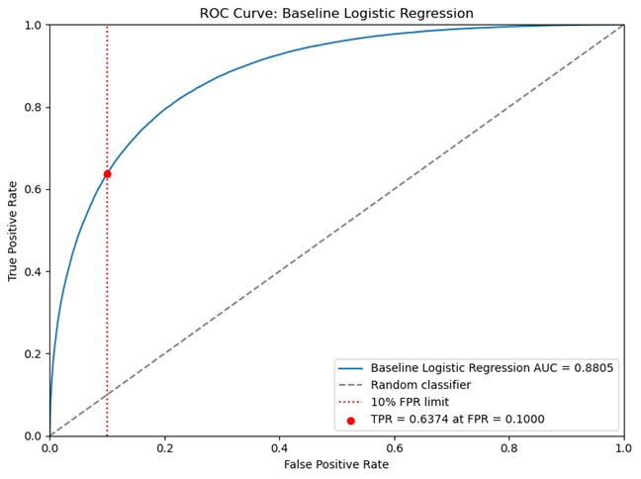
Figure 8. Full-feature logistic regression ROC curve without holiday features. The model achieves AUC = 0.8805 and TPR = 0.6374 at 10% FPR.
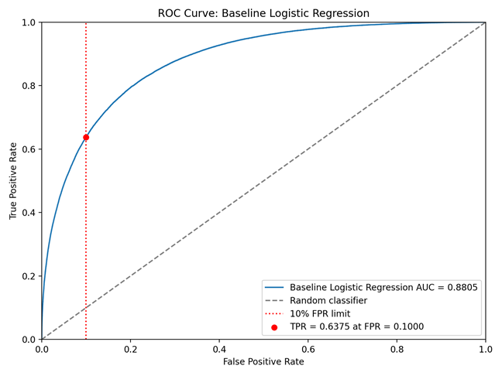
Figure 9. Full-feature logistic regression ROC curve with holiday features. Performance is almost identical to the no-holiday version.
Inference: The full-feature logistic regression model performed far better than the business-only logistic baseline. This confirms that the engineered user and tips/review features added substantial predictive signals. However, the external holiday features improved logistic regression slightly. TPR increased only from 0.637448 to 0.637500, and AUC slightly decreased from 0.880496 to 0.880487. This difference is too small to claim a huge meaningful lift from holidays for the logistic model.
The external holiday features produced only a negligible improvement for logistic regression. However, we retained them because they provided additional temporal context and were included in the final feature pipeline. The final blended model with holiday features achieved TPR = 0.7352 at FPR = 0.0970.
The final model was a weighted blend of the top models from the model zoo. The blend combined multiple LightGBM variants, XGBoost variants, and an MLP ensemble. Candidate blend weights were optimized through random search over 30,000 candidate blends on a sampled validation set, followed by full validation evaluation of the top 300 candidates. This approach can improve performance because different model families capture different patterns and make different errors.
Final Blend Detail | Reported Value
Model family | Top-K ensemble of LightGBM, XGBoost, and MLP models
Features | All numeric features from the full feature pipeline, approximately 130+ engineered variables after target encoding
Rows used | 400,000 rows
Alpha values tested | 0.15, 0.25, 0.5, 0.8, 1.0, 2.0
FPR with holiday features | 0.096996
TPR with holiday features | 0.735227
Reported validation AUC | 0.879
OOF AUC reported in ensemble section | 0.8953

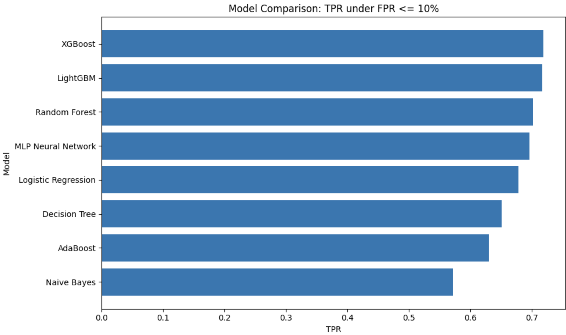
The blended model achieved the best reported operating-point performance, with TPR = 0.7352 at FPR = 0.0970. This means the final model identified approximately 73.5% of positive cases while keeping the false positive rate below 10%. Even though one reported validation AUC value for the blend is lower than the LightGBM CV AUC, the blend produced the strongest TPR at the target FPR, which aligns with the project's main evaluation objective.

Section 5: Reflection/takeaways
Our group worked very well collaboratively to figure out which model was the best. Nobody was upset when another model was chosen as the one to submit for the week, in fact, it was encouraged that everybody get to submit at least one model, so we can see the differences between what our TPR and FPR were and compare them with the final submission. We communicated when we had breakthroughs with our models and shared interesting things we noticed during the feature engineering portion of the project.
The models we were running for this project were computationally very heavy. In the beginning, we realized that we were unable to run this on Google Colab since we thought that would be the easiest way to collaborate. We then started running our own models locally in VSCode, as it had better computational power. Lastly, we moved to Kaggle since it allowed us to run larger subsets of data without running out of local storage. Trying to navigate how to run more complicated models on computers that weren’t built to handle computationally heavy models with such large datasets was something that took a while to navigate.
If we could start the project again, we would try to collaborate in feature engineering and communicate smaller findings so that we can build on each other's work rather than communicating milestones. If we worked on the same cleaned datasets and selected the same features, we would be able to find important features a little bit faster and more accurately. Since not all models will have the same set of best features, we can only use those features as general guidelines and not the standard. If we had more time to work on the project, we would have focused more time on integrating our different models together. We came back after individually working to compare our models and helped each other through any difficulties building them, but we weren’t able to work on the same files due to long runtimes.
For someone starting the project next year, we would recommend that teams start collaboratively from the start and decide on a collaborative folder to work out of early on. It’s okay to split up models in the beginning, but once certain people start doing some feature engineering, agree on the best features to use and modify, and have consistent knowledge of each other's most important features. We noticed that some of our model discrepancies came from how well we were able to feature engineers, and since this part of the project is really crucial to fully compare different models.

